My Favourite Things presented by the Bouddi Birds
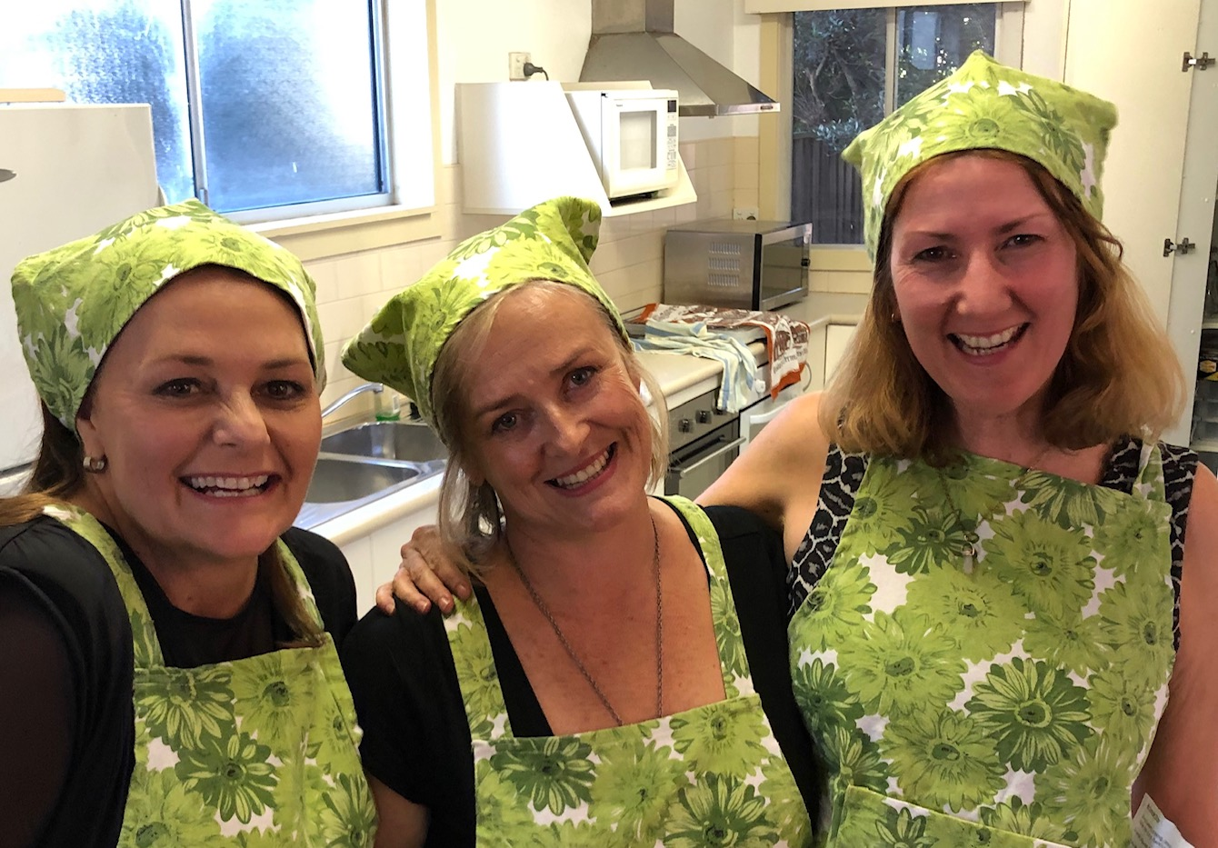

Etching or weaving, sculpting, ceramics
Whatever they’re doing, there’s no need to panic.
Our talented artists can make anything,
these are a few of our favourite things.

They work with paper, leather and glass.
Whatever they model, it’s made with class.
The beautiful jewellery makes our hearts sing,
These are a few of our favourite things

When the pot cracks
When the thread breaks
When we’re feeling sad
We simply remember our favourite things
And then we don’t feel, so bad.

Selwyn, Stott, Tapping, Trigg and Sonasi
Some of the artists get a little bit Sassy
Waters and Austin, Bennetts, Boonaerts and Boyle
They love it so much, to them it’s not toil.

Cavender, Cameron, Burnstein and Brown
Daviel and Hansen we’ve seen around town.
Haymes, Koppen, Krebs. Loker, McManamey
Have Pemberton, Peters and Riemann for tea.

When the pot cracks
When the thread breaks
When we’re feeling sad
We simply remember our favourite things
And then we don’t feel, so bad

With apologies to original Songwriters: Oscar Hammerstein / Richard Rodgers

